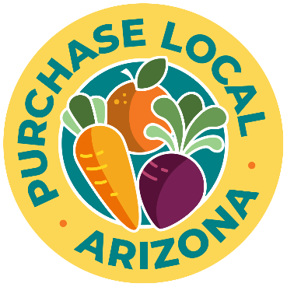
Proposed Produce Pick-up and Partnership
The Farm will procure the products listed below and then deliver to the Distribution site address indicated below.

Distribution Contact: Name, Contact phone, | email
Distribution location 1: Name, Address
Effective dates: [start date and end date]
Distribution Date | Distribution Location | Product | Specs | Quantity | Price | Total cost
Weekly for ten weeks beginning  July 1, 2023 | ABC Food Bank  123 Main Street,  Phoenix 85000 | Assorted Produce Boxes | Seasonal produce- cabbage head, cucumber, melon, cherry tomatoes, zucchini | 125 boxes | $14/box | $1,750.00
 |  |  |  |  | TOTAL | $1,750.00

